Module Teaching
- General information

The name of the teacher | Dita Deviana Rachmawati
Which school are you from | Universitas St. La Salle
Phase/ class/ number of children | Fondasi/ Kinder B / Kinder A
Topic | Plants
Learning model | Discussion and lecture
Time Allocation | 2 meetings
Learning objectives | - Religious values and character  - Children practice worship activities according to religious teachings  - Children can know the creation of God  - Self esteem  - Children demonstrate simple plant parts and plant needs  - Fundamentals of literacy and steam  - Children speak in a state of more complex sentences
Learning Resources | Learning Video  - Image about the green for spark learning topics  https://drive.google.com/file/d/1vT6GU_rK08g-mLLIZKMRzo0duEyRAWXl/view?usp=drive_link  2) video parts of plans for materials  https://youtu.be/TD60-3rqPXg?si=b6wMzS-ZFT73wUn7  3)Video needs of plants for materials  https://drive.google.com/file/d/1wW7LWDFZlDkRAJHoXtRdUch7KMtgNet5/view?usp=drive_link
General Description of Activities | Child given strengthening about watching videos. Children will learn, such as:  - Plants parts  - Plan needs  - Benefit of plants
Concept maps | 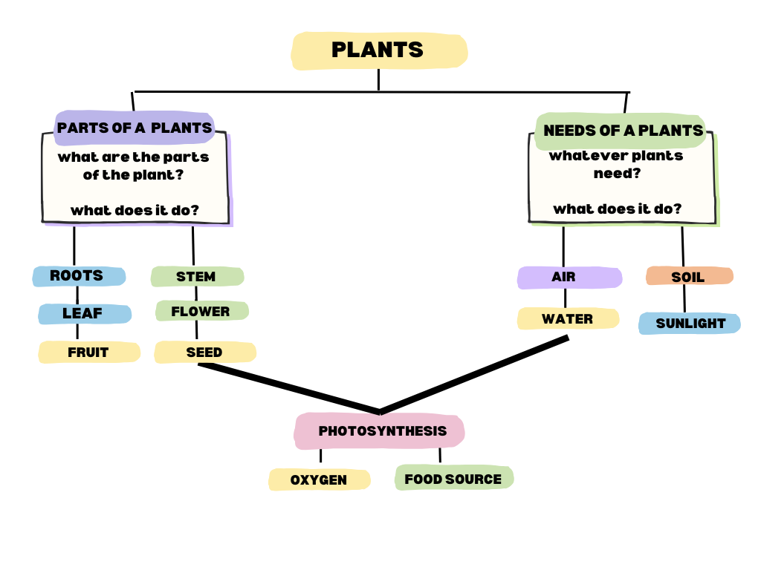

- Langkah-langkah Pembelajaran

Assesmen awal

No | Learning objectives | Achievement Indicator | Activity | Observation result | Recommendation
1 | Children practice worship activities according to religious teachings | Child can Practicing the activities of worship accordingly teachings | Children pray before studying
2 | The child can know the creation of God | Child can actively participating actively recognizing God's creation | Watching videos
3 | The child demonstrates simple parts of the plant and plant needs | Child can Explain plant parts and plant needs | Children work on worksheets
4 | Children speak in a state of use using more complex sentences | Children can tell their experiences about plants | sharing experiences

- Lesson Plan
Group/age : A dan B / 5-6 tahun
Topic : Plants

Friday, February 7, 2025
Learning activities:
- Intraculicular Activities
          - Opening
- Religious activities, singing songs
- Greet children and teachers in class
- Asking for children and children's feelings
- The teacher invites discussions about plants
          - Core Activities (09.00 – 09.45 dan 10.15 – 10.45)
a) See pictures and watch videos  b) invite to tell stories about experience they are in a garden or garden  c) Working on a worksheet | Kinder B  - See images and watch videos about “Parts of plants”  - Attach Parts of plants  - Draw a garden | Kinder A  - See images and watch videos about “Needs of plants”  - Coloring plants  - Matching needs of plants
Tools and materials
Laptop, screen, worksheet | Pictures and videos, worksheets, pencil, eraser, crayon, glue | Gambar dan video tanaman, lembar kerja, pencil, eraser,crayon,
          - Recess Time (09.45 – 10.15)
- Closing (10.45 – 11.00)
1) Reflection of activities that have been carried out
2) Pray and go home
Reflektion :
Assessment: Work, Anecdotal Notes, Checks are done by doing: Documenting the process of learning activities and children's work results
Knowing,  Teaching Coordinator  Vevs B. Gelisanga |  | Bacolod, 05 Februari 2025  Teacher    Dita Deviana Rachmawati

